Name: | case_1 locked_out_user can checkout
Steps |  | Expected result | Screenshot
* Open url https://www.saucedemo.com. |  | The login page must be opened. | 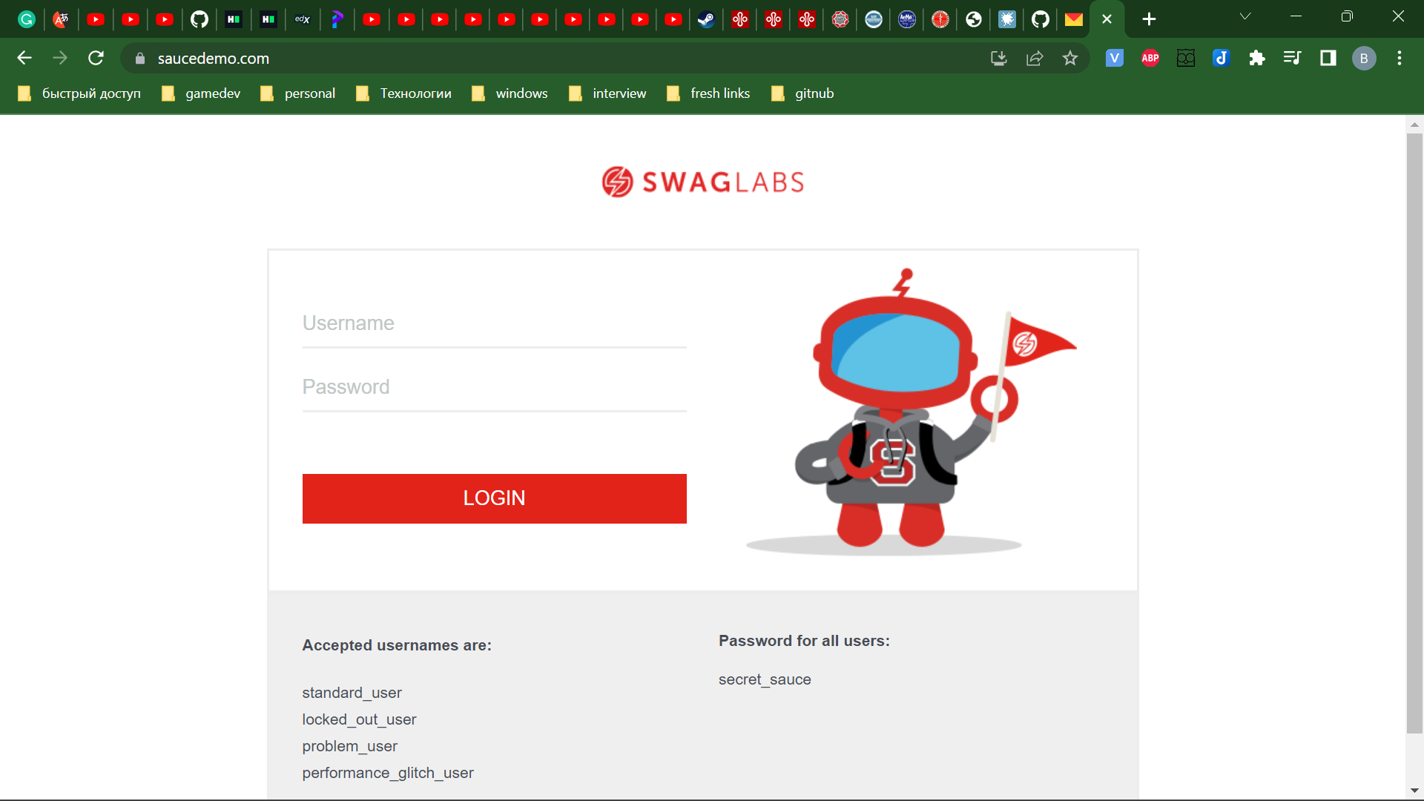
* Set username “standard_user”.  * Set password “secret_sauce”.  * Click the “LOGIN” button. |  | The products page must be opened. | 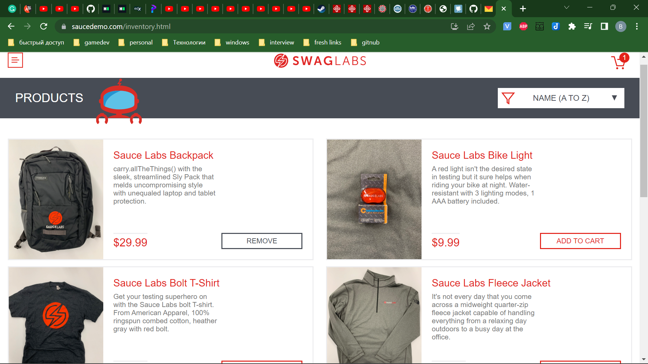
* Click on the Open Menu button at the top left corner .  * Afterwards, click the RESET_APP_STATE button  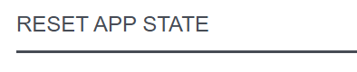. |  | The cart is empty. | 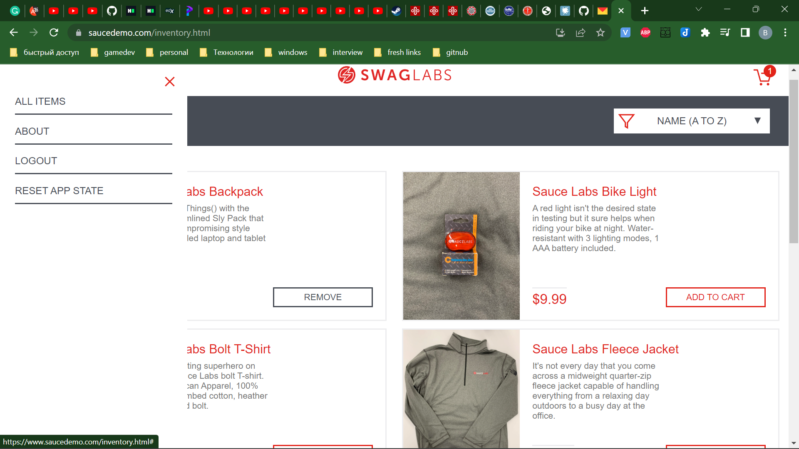
* Select two random items from the “PRODUCTS” page by clicking the “Add to cart” button.  * Click to cart at the top right corner . |  | The checkout overview page must be opened with two items in it. | 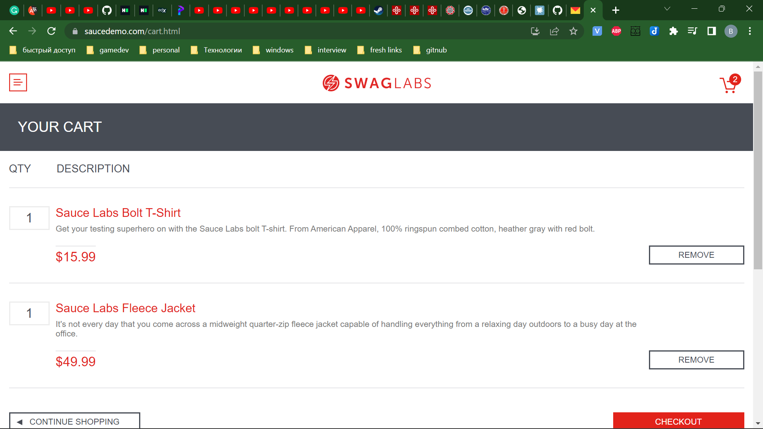
* Click the “CHECKOUT” button. |  | The “YOUR INFORMATION” blank page must be opened. | 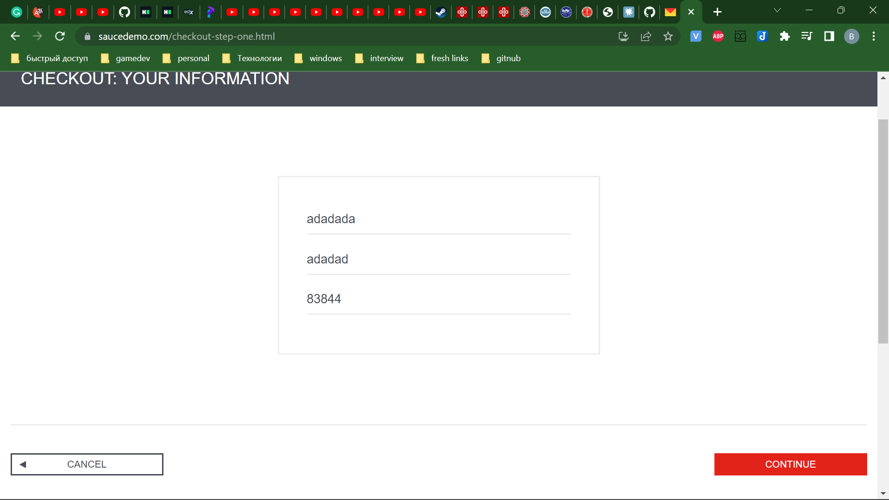
* Set First Name, Last Name, Postal Code by some values.  * Click the “CONTINUE” button. |  | The “CHECKOUT: OVERVIEW” page must be opened. | 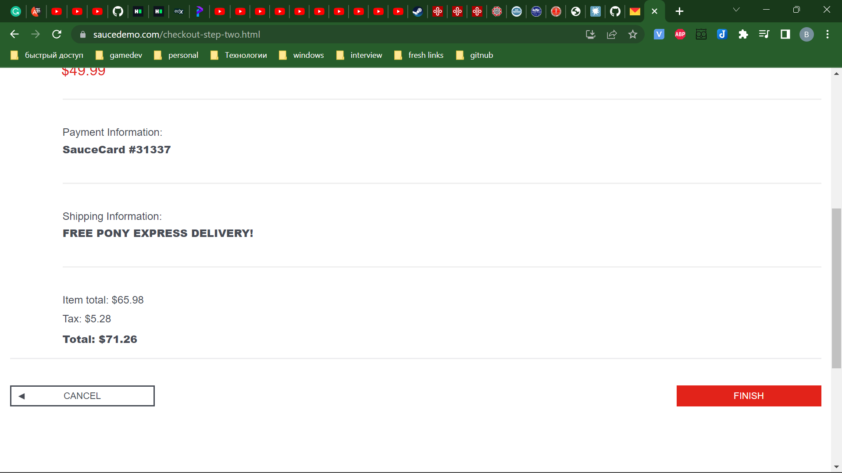
* Verify the prices. |  | The “item total” price  is equal to the price of items added on the “PRODUCTS” page.
* Click the “Cancel” button.  * Click on the Open Menu button at the top left corner .  * Afterwards, click the “LOGOUT” button. |  | Successful logout from saucedemo.com back to the login page. | 